**1. SQL Exercise - Advanced concepts**

**Exercise 1: Ranking and Window Functions**

CREATE TABLE Products (

ProductID INT,

ProductName VARCHAR(100),

Category VARCHAR(50),

Price DECIMAL(10, 2)

);

INSERT INTO Products (ProductID, ProductName, Category, Price) VALUES

(1, 'Apple iPhone 14', 'Mobiles', 900),

(2, 'Samsung S21', 'Mobiles', 800),

(3, 'OnePlus 10', 'Mobiles', 850),

(4, 'Redmi Note 10', 'Mobiles', 300),

(5, 'LG OLED', 'TV', 1500),

(6, 'Samsung QLED', 'TV', 1400),

(7, 'Sony Bravia', 'TV', 1450),

(8, 'MI TV', 'TV', 700),

(9, 'HP Laptop', 'Laptops', 1200),

(10, 'Dell XPS', 'Laptops', 1250),

(11, 'Asus ROG', 'Laptops', 1300),

(12, 'Lenovo ThinkPad', 'Laptops', 1150);

SELECT *

FROM (

SELECT *,

ROW_NUMBER() OVER (PARTITION BY Category ORDER BY Price DESC) AS RowNum

FROM Products

) AS Ranked

WHERE RowNum <= 3;

SELECT *

FROM (

SELECT *,

RANK() OVER (PARTITION BY Category ORDER BY Price DESC) AS RankNum

FROM Products

) AS Ranked

WHERE RankNum <= 3;

SELECT *

FROM (

SELECT *,

DENSE_RANK() OVER (PARTITION BY Category ORDER BY Price DESC) AS DenseRankNum

FROM Products

) AS Ranked

WHERE DenseRankNum <= 3;

**OUTPUT:** 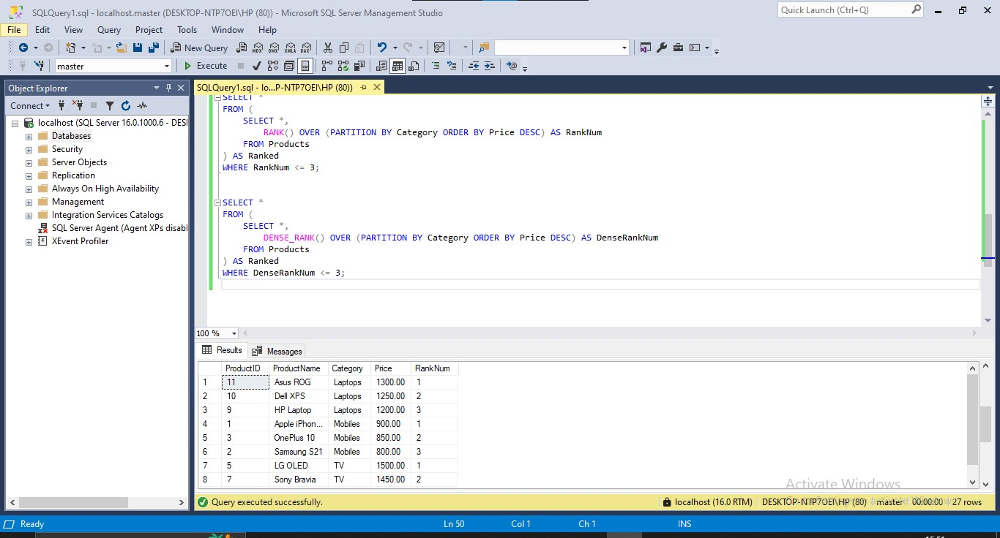

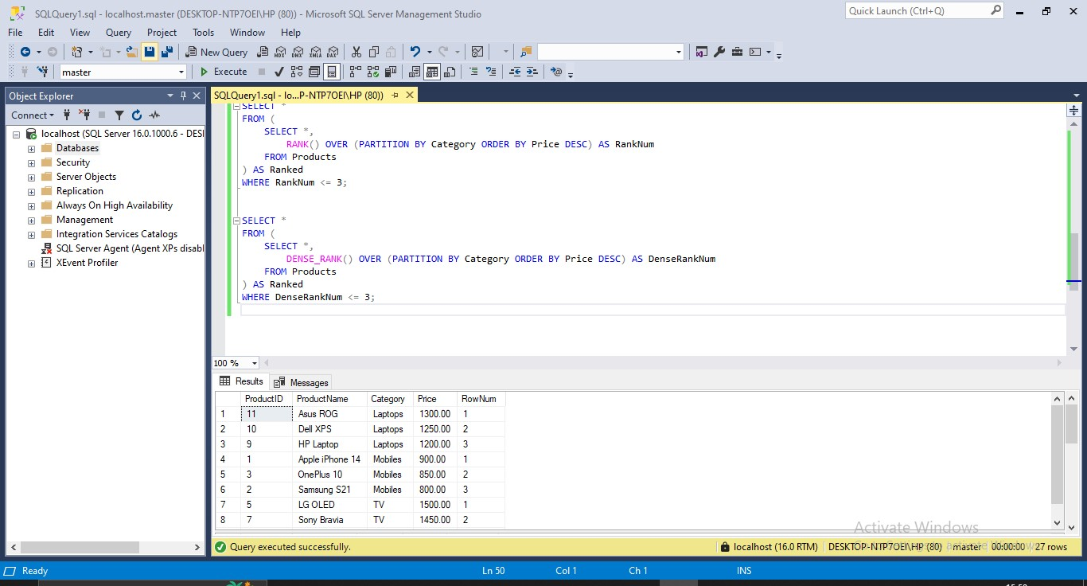

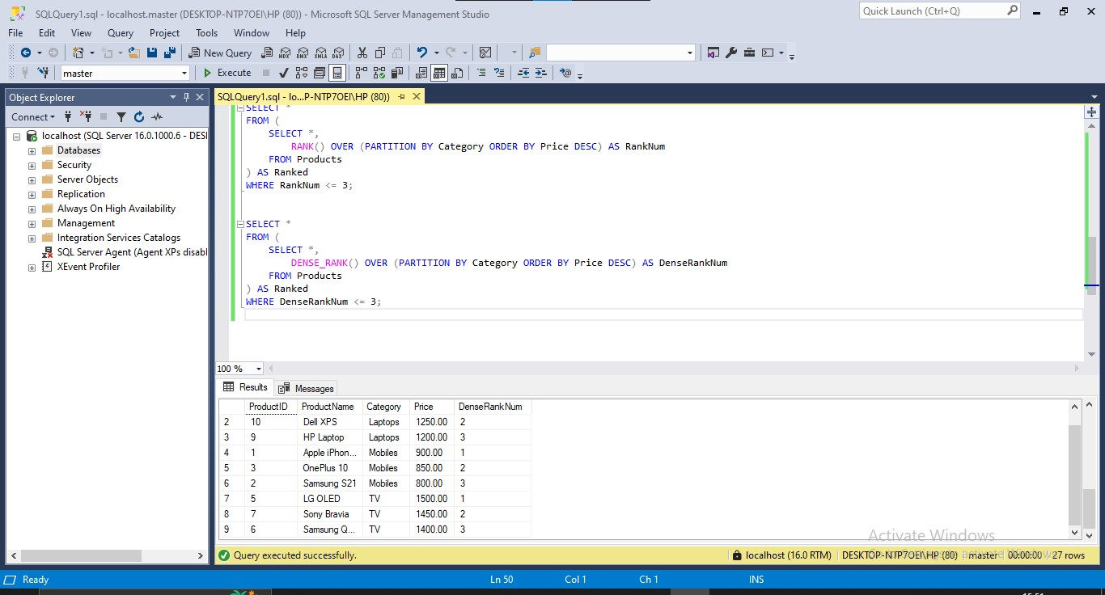

**4. SQL Exercise - Stored procedure**

**Exercise 1: Create a Stored Procedure**

EXEC sp_InsertEmployee

@FirstName = 'Rithi',

@LastName = 'Krithi',

@DepartmentID = 3,

@Salary = 7500.00,

@JoinDate = '2023-06-29';

EXEC sp_InsertEmployee 'Arjun', 'Mehta', 1, 5200.00, '2020-02-10';

EXEC sp_InsertEmployee 'Priya', 'Verma', 2, 6300.00, '2019-06-18';

EXEC sp_InsertEmployee 'Rajesh', 'Iyer', 3, 7200.00, '2021-03-25';

EXEC sp_InsertEmployee 'Anjali', 'Nair', 4, 5800.00, '2022-01-12';

EXEC sp_InsertEmployee 'Deepak', 'Reddy', 3, 7100.00, '2023-05-03';

EXEC sp_InsertEmployee 'Kavya', 'Sharma', 2, 6450.00, '2020-11-09';

EXEC sp_InsertEmployee 'Naveen', 'Das', 1, 4950.00, '2021-09-15';

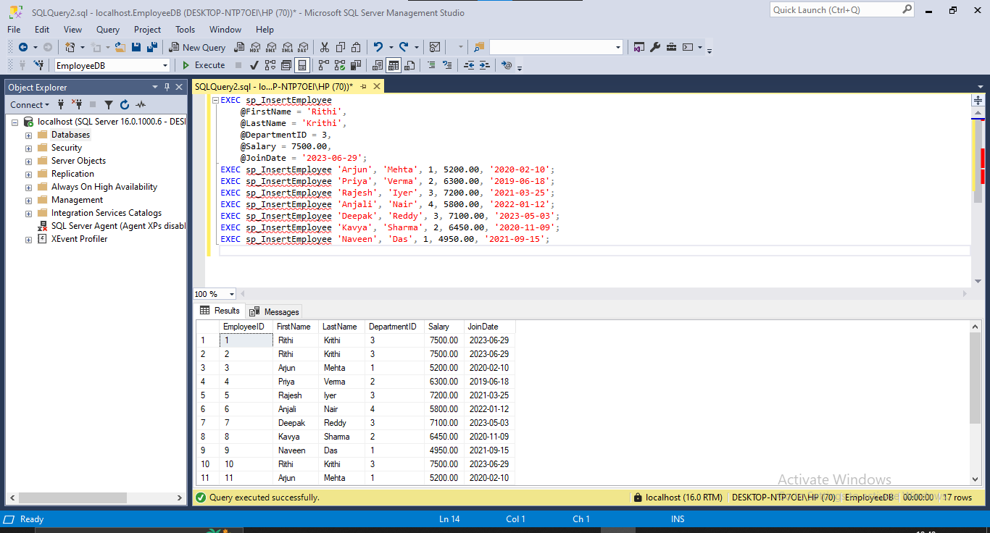

**Exercise 5: Return Data from a Stored Procedure**

CREATE PROCEDURE sp_CountEmployeesByDepartment

@DepartmentID INT

AS

BEGIN

SELECT COUNT(*) AS TotalEmployees

FROM Employees

WHERE DepartmentID = @DepartmentID;

END;

GO

EXEC sp_CountEmployeesByDepartment @DepartmentID = 3;

